V. Madesh 192312553
Code:

clc;
clear;
close all;

N = 20;
Wn = 0.4;

% Fourier Series method
b1 = fir1(N,Wn,rectwin(N+1));

% Windowing methods
b2 = fir1(N,Wn,hamming(N+1));
b3 = fir1(N,Wn,hann(N+1));

% Frequency response
[H1,w] = freqz(b1,1,512);
[H2,~] = freqz(b2,1,512);
[H3,~] = freqz(b3,1,512);

plot(w/pi,abs(H1),'r', ...
w/pi,abs(H2),'b--', ...
w/pi,abs(H3),'g-.','LineWidth',1.5);

grid on;
xlabel('Normalized Frequency');
ylabel('Magnitude');
title('FIR Filter Design');
legend('Rectangula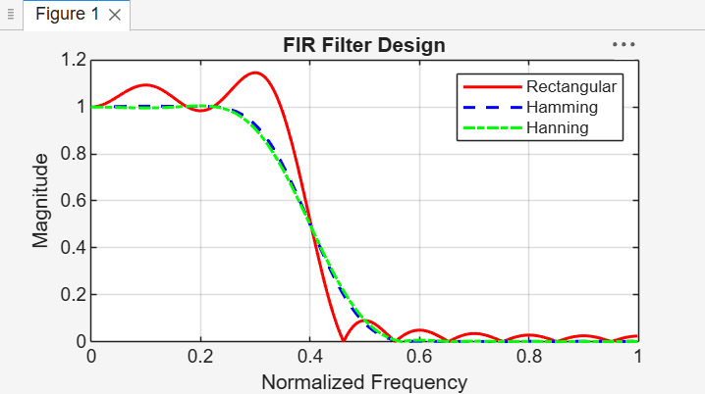r','Hamming','Hanning');

